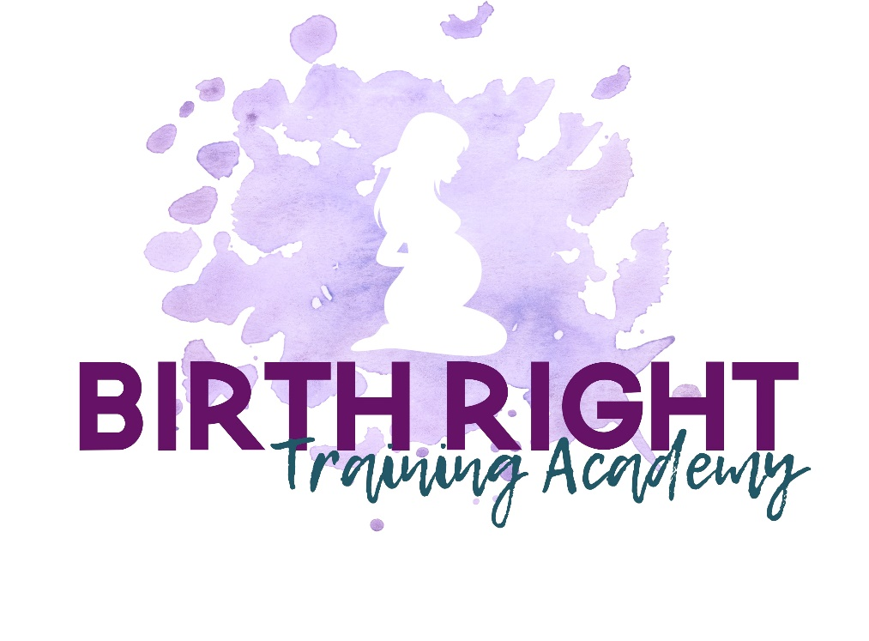
COURSE OUTLINE and FAQ’s
MODULE 1
- Medical interference in birth – our shameful statistics
- What is the role of a childbirth educator?
- Knowing ‘THE SYSTEM’
- Understanding CHOICES
- What is a doula? And why every pregnant woman deserves one
- What is the MIND? And the Role of the conscious/unconscious mind in pregnancy, labour, birth and powerful imprinting for baby
- FEAR – why do so many pregnant women have so many fears and anxieties about birth
- What is a ‘belief’

MODULE 2
- How to teach the IB program
- An overview of anatomy
- View from the INSIDE – what’s it like for baby
- Autonomic Nervous System Response
- Laws of the Mind
- Inside Birth techniques
- About DAD
- An introduction to hypnotic relaxation

MODULE 3
- Eliminating fears and anxieties
- What is a limiting belief
- Negotiating
- Birth Plans
- Relaxed and grounded Inside Birth techniques
- Creating the ‘right’ energy in classes

MODULE 4
- Stages of labour
- Mind the breath
- Group Teaching
- Roles for Dad, Midwife, Doula, Obstetrician, Anaesthetist
- Rare events in labour/birth
- Important preparation to birth as nature intended
MODULE 5
- Falling in love on the outside
- Breastfeeding
- Taking baby home – keeping baby close
- Setting up your IB business

On completion of this online course, you will receive all necessary materials for teaching the program plus certification and logo to use on your advertising material. Easy to teach power point presentation. Full slides, including handouts, scripts, included.
Mentoring is available for all trainees.

FAQ’s
Can I make money as an Inside Birth® Educator?
The practical and very important stuff! Yes. You have the opportunity to make money as an Inside Birth® Childbirth Educator. In fact, your commitment for this training should repay you with your first set of classes.
What if I have another job?
Becoming an Inside Birth® Educator is life changing. This cutting-edge training will change your thinking about how we enter the world and why that is important.
You can choose to make this a full time or part time career. The Inside Birth® prenatal program is run over 4 weeks or weekend workshops and we offer a unique dip in/dip out package for pregnant couples.
What support is offered?
Support is available whilst you are studying. A mentoring program is offered post-graduation. You will receive a free profile on our website advertising all your class details.
Do I need teaching experience?
No. This program is set out for you with an easy power point presentation, with beautiful images and all text, hypnotic relaxation scripts included. It is a joy to teach and watch the amazing transformation from fears to excitement and confidence in all your pregnant clients.
Still got questions?? please call me directly: Susan 0419606171
Or susan@birthright.com.au

