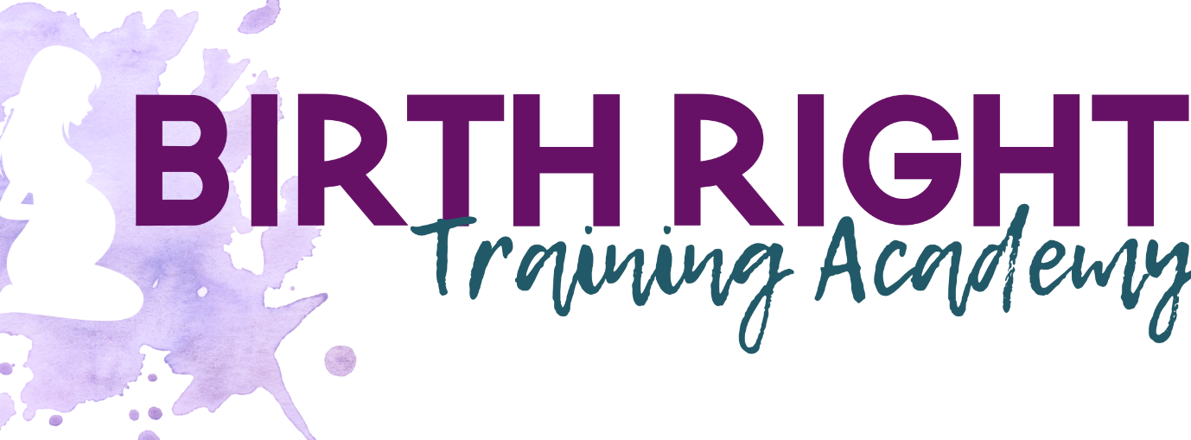

OUR PAYMENT PLAN OPTIONS
We offer payment plan options as a service to you. I don’t want you to miss out on reaching your goal of helping pregnant/birthing women and new parents.
Flexible payment plans include:
- x 2 payments ($698.50)
- x 4 payments ($349.25)
- Payment weekly or fortnightly OR
- Contact Susan directly to organise a plan that suits you
Your Commitment:
- You must ensure there are sufficient funds in your account for the designated dates of each payment
- You will receive the Course once full payment is completed
- Included is mentoring and support throughout your study via phone or Zoom. You must book a time with Susan.
- You can view our Privacy Policy here: https://birthright.com.au/privacy-policy/

Please respect this option and ensure funds are available when payments are due.

